Andrew Ferreira

Digital Arts, SP 18

Senior Project Statement:

As part of my senior project I designed two characters. I started off with an idea. I wanted to create a baby and mother of an animal but I didn’t know which. I am a big fan of Harry Potter, so while re-watching Chamber of Secrets I decided that I will create a Phoenix. If you work in the animation industry, you will realize that everything comes in steps.

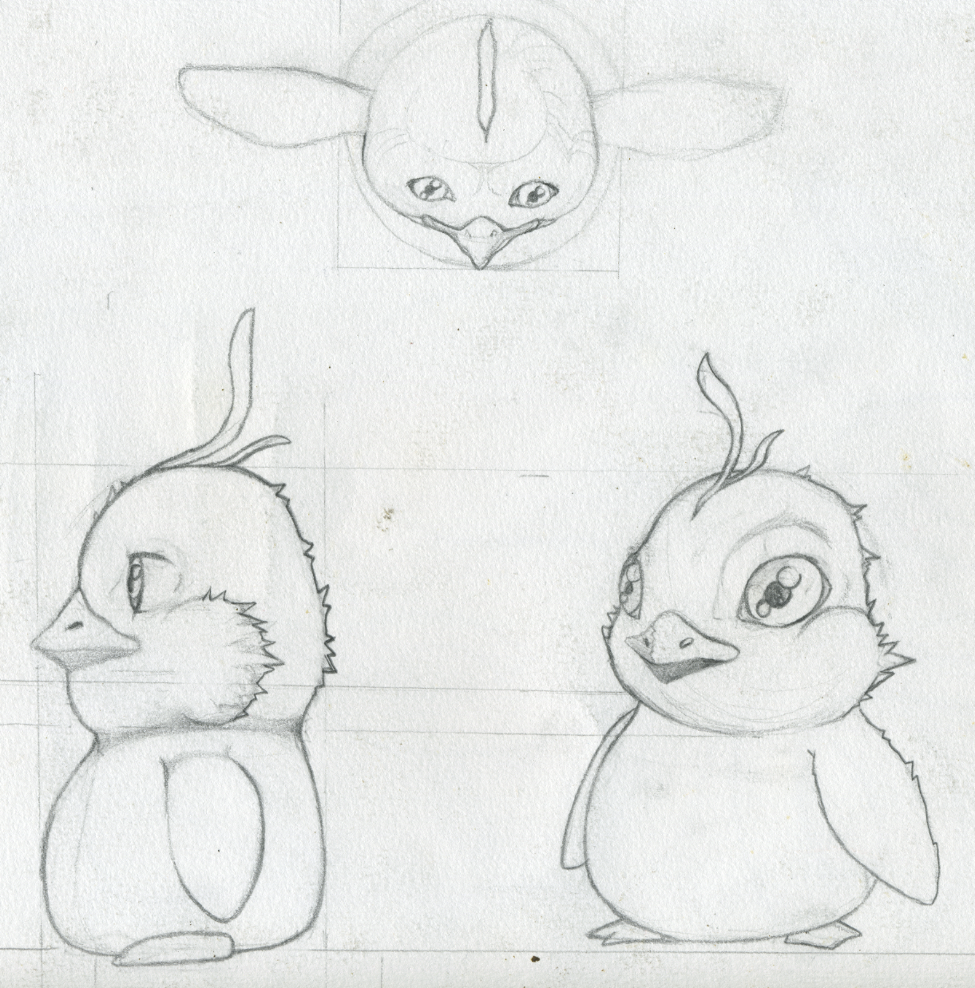 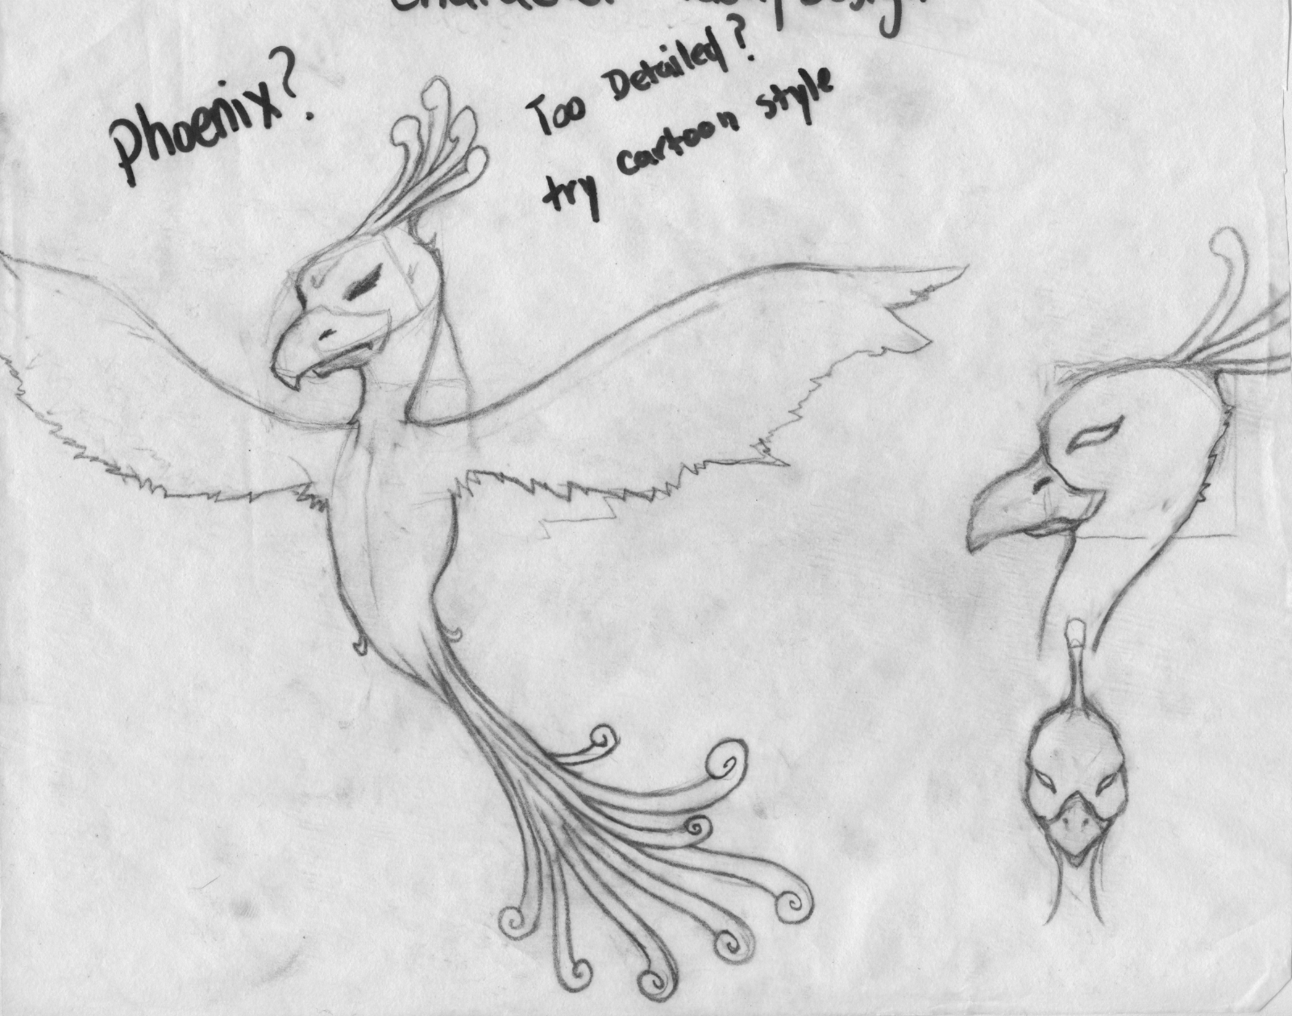

First, I drew up rotoscopes of what I wanted both the mother and baby to look like by creating the different rotoscopes of the side, front, and top view. A rotoscope is a rough sketch of different perspectives. Using these rotoscopes, I 3D modeled and textured both characters.

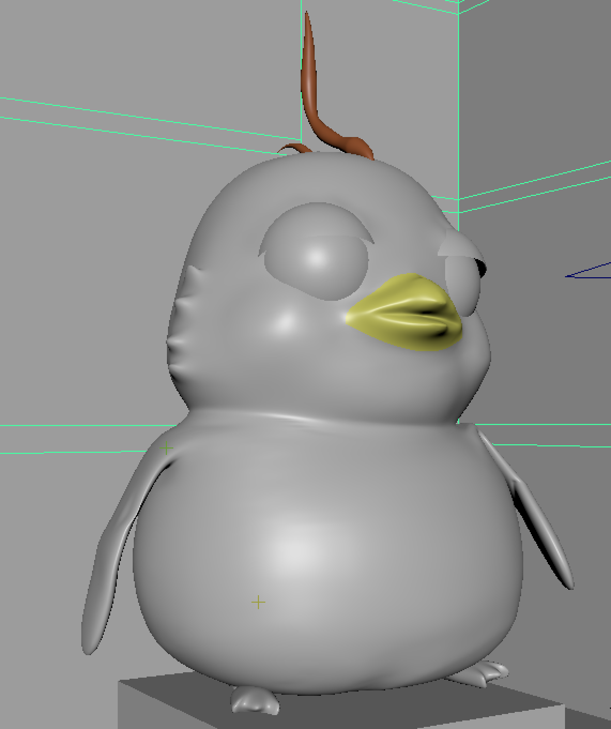 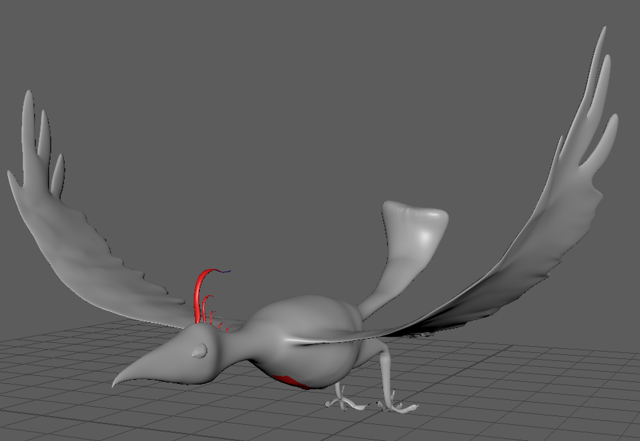

I wanted to have the ability to animate my characters so I used the knowledge of rigging learned in 317 to create a skeleton for the characters. The skeleton is designed so that I can move the phoenix wings realistically and smoothly.

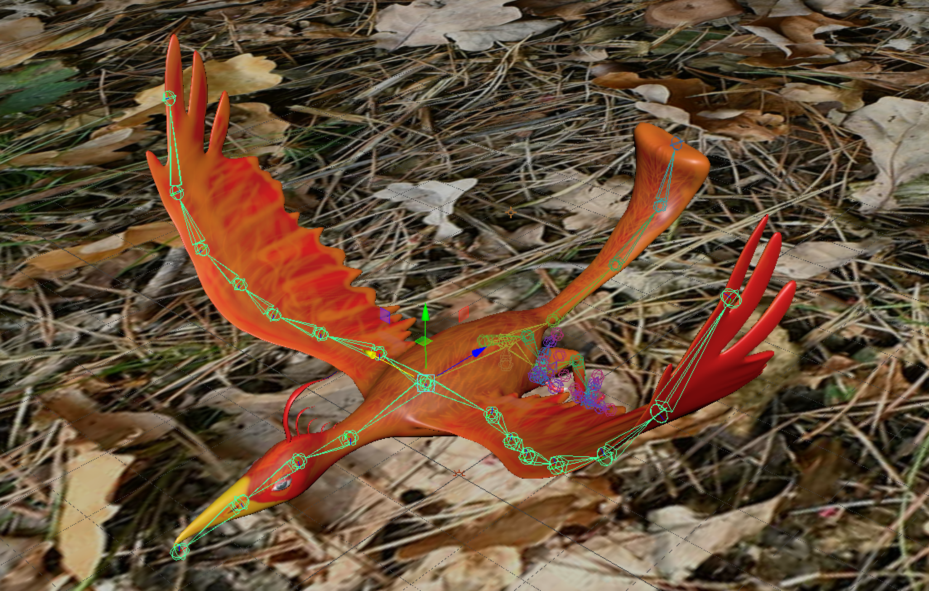 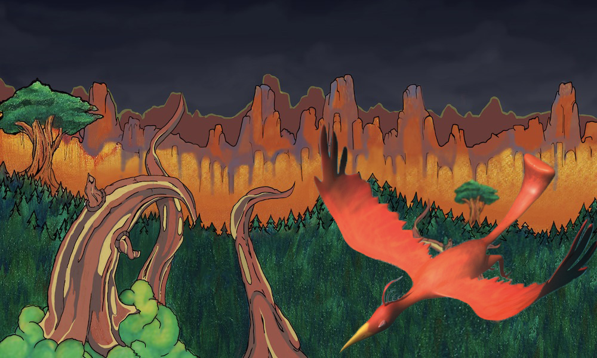

In addition to 3D modeling and texture, rigging and animating, I wanted a physical copy. Using state of the art equipment and a very smart individual I was able to have my models made into physical copies.